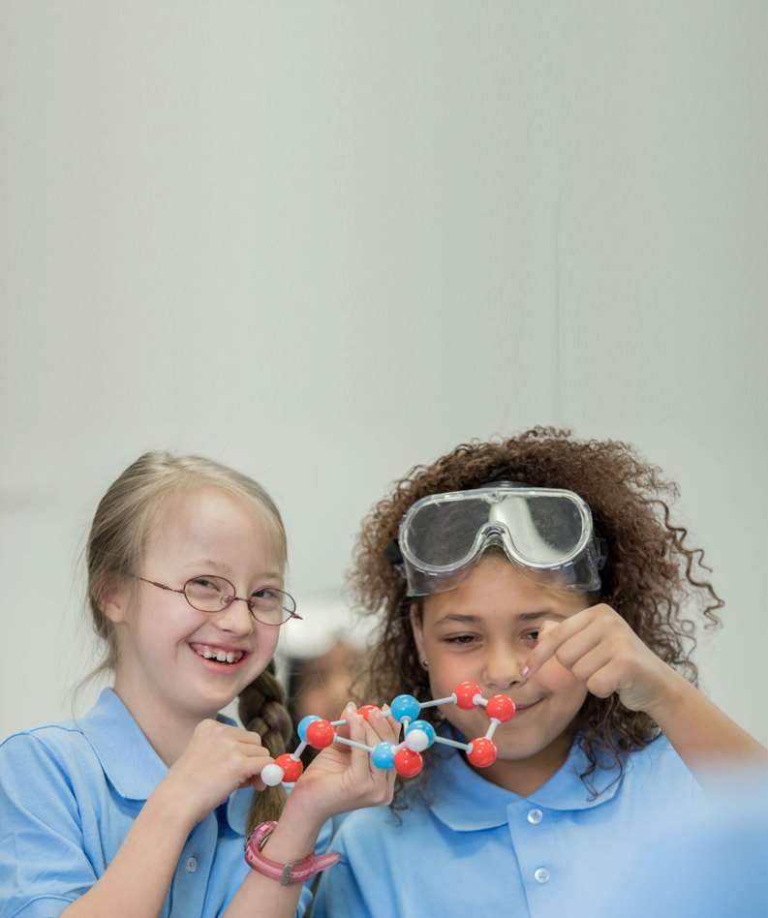

Invest in children and young people with disability:
their voices and their future

PRE-BUDGET 2023–24 SUBMISSION

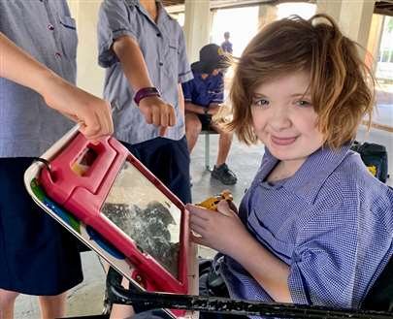

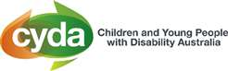

Children and Young People with Disability Australia
January 2023

Contents

A Introduction
B Invest in their future
C Invest in their voices
D Targeted investment areas
E Facts and figures
F Resources

Authorised by:
Skye Kakoschke-Moore, Chief Executive Officer
Contact details:
Children and Young People with Disability Australia
E. skye@cyda.org.au
P. 03 9417 1025
W. www.cyda.org.au

Acknowledgements
Children and Young People with Disability Australia would like to acknowledge the traditional custodians of the lands on which this report has been written, reviewed and produced, whose cultures and customs have nurtured and continue to nurture this land since the Dreamtime. We pay our respects to their Elders past, present and future. This is, was and always
will be Aboriginal land.

A
Invest in children and young people with disability to improve outcomes, ensure equity and bring benefit to future outcomes

Introduction

Children and Young People with Disability Australia (CYDA) is the national representative organisation for children and young people with disability aged 0 to 25 years. CYDA has an extensive national membership of more than 5,000 young people with disability, families and caregivers of children with disability, and advocacy and community organisations.

CYDA welcomes the opportunity to provide a 2023–24 Pre-Budget Submission. The Australian Government, through the Federal Budget, has the power to invest in outcomes and fund initiatives that will lead to vast improvements in the lives of children and young people with disability. By investing in interventions and strategies that will protect and empower this cohort, the Australian Government can support children and young people to thrive – now and as they transition into adulthood.

Our vision is that children and young people with disability are valued and living empowered lives with equality of opportunity; and our purpose is to ensure governments, communities, and families, are empowering children and young people with disability to fully exercise their rights and aspirations.
We do this by:
- Driving inclusion
- Creating equitable life pathways and opportunities
- Leading change in community attitudes and aspirations
- Supporting young people to take control
- Calling out discrimination, abuse, and neglect

CYDA urges the Australian Government to make bold and targeted investment in children and young people with disability, to maximise individual power and autonomy, and support social inclusion, safety and equality to ensure their rights are upheld and that Australia is truly an inclusive society for all its citizens.

Invest in their future
B
The landscape is changing for people with disability.
There are significant opportunities that pave the way to improve the lives for people with disability, including for children and young people.

References:
1 ACOSS (2022) Budget Priorities Statement 2022-2023 Submission to the Treasurer
2 Commonwealth Government of Australia (2022) Building a better future for Australia
CYDA accords with Australian Council of Social Service (ACOSS), that there is no urgency to reduce the budget deficit.¹ CYDA supports the government's strategy to “responsibly manage the Budget, by paying for the things that Australians value the most”.² We therefore urge the government to prioritise investment in the 4.4 million Australians with disability by funding a coordinated approach to properly address the significant work which lies ahead, including the final report from the Disability Royal Commission, Australia’s Disability Strategy, upcoming changes to legislative frameworks and other inquiries and reviews.
This work should be underpinned by the principles outlined in the United Nations Convention on the Rights of Persons with Disabilities (UNCRPD). Such a coordinated approach is crucial to both the successful implementation and on-going monitoring of the following instruments and frameworks.
The funding of co-design with children and young people with disability — developed through a comprehensive consultation and engagement process — will also be crucial to its success.

Invest in their voices
C

The voice of children and young people should be heard at different levels:
- local/individual level influencing change for daily living
- structural level for change in systems
- systemic level to bring change at a society/policy level

This submission recommends that the government calibrates its approach to investment and policy formulation to ensure children and young people with disability are at front and centre of the changes that affect them. The government must therefore shore up expenditure for disability advocacy and the Office of Early Childhood Education and Youth as a purposeful mechanism for allowing children and young people to have meaningful input into the changes that affect them. We also recommend funding investment to develop and implement a National Child and Young Person with Disability Engagement Framework.

CYDA believes that participation by children and young people in advocacy and change-making can not only improve and foster positive change in their own lives, but also influence the lives of others. This has the potential to shape policy, to increase the relevance and responsiveness of organisations they use, and to influence change in their communities in positive ways.

Investing in the voices of children and young people with disability can be done by:
- creating pre-planned and paid co-design roles and structures
- advisory groups of young people with lived experience to provide input in a coordinated and regular way
Benefits of co-design
Co-design can be understood through the lens of equality—where all people are treated, represented, and supported fairly and equitably. This covers individual, day-to-day interactions but also extends to representation in the community, permitting input into program design and draft legislation, and the upholding of human rights consistent with the UN Convention on the Rights of Persons with Disabilities (UNCRPD). Co-design can have profound benefits for all stakeholders including government, end-users, people with disability and the wider community.
Benefits include:
- achieving a stronger outcome which draws on a wide range of perspectives and expertise
- encouraging greater ownership of, and commitment to, the outcomes by all stakeholders involved, including the disability community
- testing ideas with intended users/beneficiaries
- upholding the rights of people living with disability under the CPRD

Targeted investment areas
D

 | Area 1: Involve and engage children and young people with disability across all government portfolios impacting their lives | Children and young people with disability often face barriers to participating in consultative activities that inform policy and service development. This breaches children and young people’s rights and risks government investing in actions that will fail to provide targeted supports where most necessary. Ongoing and targeted funding is required to develop and implement a National Child and Young Person with Disability Engagement Framework.  Future benefit: increase engagement, reduce marginalisation, increase effectiveness of investment, and facilitate and identify role models and leaders
 | Area 2: Adequately resource Australia’s Disability Strategy’s (ADS) key actions and targeted action plans (TAPs) | The ADS includes key actions and TAPs with a specific focus on children and young people with disability, which will have lifelong benefits. CYDA urges the allocation of sufficient funding to implement a focus on whole of life approaches and understanding across all areas. This starts with establishing and funding programs to ensure children and young people with disability and their representative organisations are meaningfully included in guiding and monitoring the progress.  Future benefit: children with disability will attain improved health and wellbeing outcomes to assist them to live independently and engage more fully in their communities.
 | Area 3: Develop and implement a targeted National Youth Disability Employment Strategy | Young people with disability experience high rates of unemployment and underemployment with the intersectional disadvantage of being a both young person and a person with disability in the labour market. We call on the government to co-design and implement a nationally consistent post school transition supports framework which focuses on career progression from school and provides earlier employment support to young people.  Future benefit: early career investment will set young people up for life, measurably improving their capacity for economic participation.
 | Area 4: Drive and fund transformational change to ensure inclusive education | Australia’s education system does not adequately support the learning and full inclusion of children and young people with disability. Segregation of students with disability in special schools and classes continues, despite compelling evidence that inclusion in regular schools leads to better short and long-term outcomes for all students.  Future benefit: opens up all to their full potential through education and learning, paving a path to an inclusive life with greater economic and social independence later in their lives.
 | Area 5: Ensure the National Disability Insurance Scheme is fit-for-purpose for children and young people | The NDIS does not take into account the holistic needs of those aged under 25. Young people with disability are the experts of their own experience. Further investment in the current NDIS Review would ensure that young people are supported to speak about how the NDIS is working for them and where change is needed.  Future benefit: investing in consultation with young people will boost cost effectiveness as driven by the participants themselves.

Facts and figures

E

Intersecting discrimination and exclusion spans the medical and health service sector, educational systems and the community, all while they are also going through a significant and once in a lifetime developmental phase. This discrimination and exclusion can have lifelong impacts if not addressed early.
Children and young people with disability face intersecting discrimination and exclusion from the earliest ages.

Source:
Australian Institute of Health and Welfare (2022) People with disability in Australia, AIHW, Australian Government, accessed 23 January 2023
At a glance we know:
Prevalence:
- 7.6% of children aged 0–14 have disability
- 9.3% of people aged 15–24 have disability

Education:
- 89% of school-age (5–18) children with disability go to school
- 1 in 10 school students have a disability
- 89% of school students attend mainstream schools settings
- 71% of students with disability attend only regular classes in a mainstream school
- 18% attend special classes within a mainstream school
- 12% go to a special school

Supports:
- 57% of school students with disability receive support at school
- 29% of school students with disability attending only regular classes in a mainstream school, need support but do not receive it or need more support than they receive
- 33% of school students with disability attending special classes in a mainstream school need more support than they receive
- 33% of school students with disability attending a special school need more support than they receive

Achievement:
- young people with disability were more likely (64%) to face barriers to achieving their study/work goals after school than those without disability (48%)
- students with disability are less likely to complete year 12 or attain a tertiary education, such as a gaining a bachelor’s degree or higher

Employment:
- nearly half of all young people with disability are unemployed or underemployed
- 49% of young people with disability (15-24) rely on income support payments as their main source of income

The NDIS:
- 41% of participants are aged 14 and under
- 26% aged 6 and under, 19% aged 7–14, and 6.8% aged 15–18
Source: Australian Institute of Health and Welfare (2022) People with disability in Australia, AIHW, Australian Government, accessed 23 January 2023
F
CYDA’s work is rights-based and led by the direct experiences and diverse voices and visions of children and young people with disability across Australia.
CYDA grounds its work in evidence and a human rights approach.
RESOURCES
10
Boost funding for systemic and individual advocacy for children and young people with disability for better outcomes

Resources
F
CYDA’s work is rights-based and led by the direct experiences and diverse voices and visions of children and young people with disability across Australia.
CYDA grounds its work in evidence and a human rights approach.
RESOURCES

CYDA’s work on rights, recognition and attitudes
F
Our work is rights-based:
We are led by the direct experiences and diverse voices and visions of children and young people with disability across Australia
We ground our work in evidence and a human rights approach
We support First Nations young people and their communities
- CYDA’s previous pre-budget submission: Drive inclusion and equity for children and young people with disability: 2021-22 Pre-Budget submission
- Submission to the National Disability Strategy beyond 2020
- Response to the DRC’s Rights and Attitudes issues paper

CYDA’s work on employment
- ‘What young people said’ policy paper: Full policy paper - Financial security and employment
- Joint Submission – Employment White Paper: Submission to the
- Australian Treasury’s Employment White Paper
- CYDA Submission to the Senate Select Committee on Job Security Young people with disability and job insecurity
- Submission to the consultation of the New Disability Employment Support Model

CYDA’s work on education
- Report: Taking the first step in an inclusive life, Experiences of Australian early childhood education and care
- Submission to the Disability Royal Commission, Education of children and young people with disability, Submission 1
- Driving change: A roadmap for achieving inclusive education in Australia
- Standing Committee on Employment, Education and Training, education in remote and complex environments, Submission 2 and Submission 1
- 2020 Review of the Disability Standards for Education 2005, CYDA Submission
- Disability Royal Commission - Response to Restrictive Practices issues paper
- Response to the National Strategy to Prevent Child Sexual Abuse Final Development Consultation Paper
- Submission to the Senate Inquiry into on the national trend of school refusal

CYDA’s COVID-19 work
- Report “How did COVID-19 impact post-school transitions for young people with disability and how can these be better supported?”
- Report “Locked out: Vaccination discrimination for children and young people with disability”
- Report “Not even remotely fair: Experiences of students with disability during COVID-19”
- Report “More than isolated: The experience of children and young people with disability and their families during the COVID-19 pandemic”

Suite 8, 134 Cambridge Street, Collingwood 3066 • PO Box 172, Clifton Hill 3068
t: 03 9417 1025 or 1800 222 660 (regional or interstate calls)
e: info@cyda.org.au

